Rotational Angle and Angular Velocity

In Kinematics, we studied motion along a straight line and introduced such concepts as displacement, velocity, and acceleration.

Two-Dimensional Kinematics dealt with motion in two dimensions. Projectile motion is a special case of two-dimensional kinematics in which the object is projected into the air, while being subject to the gravitational force, and lands a distance away.

In this chapter, we consider situations where the object does not land but moves in a curve. We begin the study of uniform circular motion by defining two angular quantities needed to describe rotational motion.

Rotational Angle (angular displacement)

When objects rotate about some axis—for example, when the CD (compact disc) rotates about its center, each point in the object follows a circular arc.

Consider a line from the center of the CD to its edge. Each pit used to record sound along this line moves through the same angle in the same amount of time.

The rotation angle is the amount of rotation and is analogous to linear distance. We define the rotation angle $Δθ$ to be the ratio of the arc length to the radius of curvature: $Δθ=\frac{Δs}{r}$

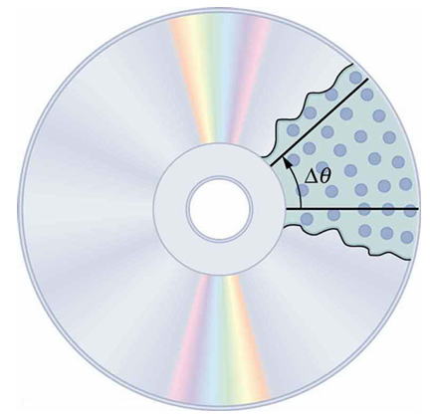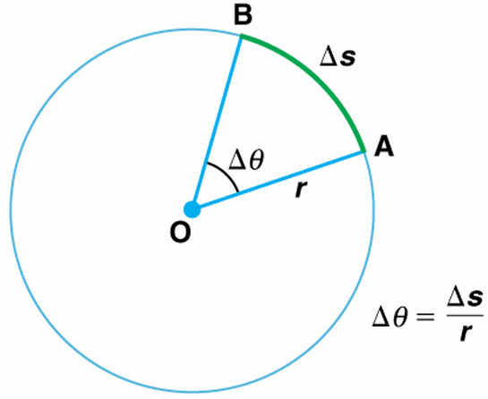

1. All points on a CD travel in circular arcs. The pits along a line from the center to the edge all move through the same angle $Δθ$ in a time $Δt$ (same angular velocity).

2. The radius of a circle is rotated through an angle $Δθ$. The arc length $Δs$ is described on the circumference.

Rotational Angle or Angular Displacement is measured in radians.
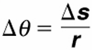 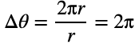,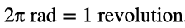, 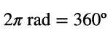, 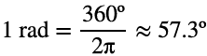
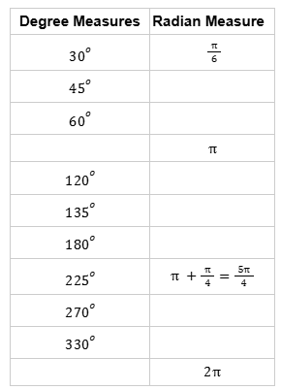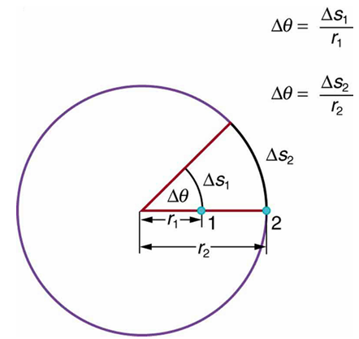
Points 1 and 2 rotate through the same angle $Δs$, but point 2 moves through a greater arc length because it is at a greater distance from the center of rotation.

Angular Velocity
How fast is an object rotating? We define angular velocity $ω$ as the rate of change of an angle $Δθ$:
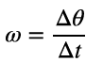
Angular velocity $ω$ is analogous to linear velocity $v$. The relationship between angular and linear velocity is:
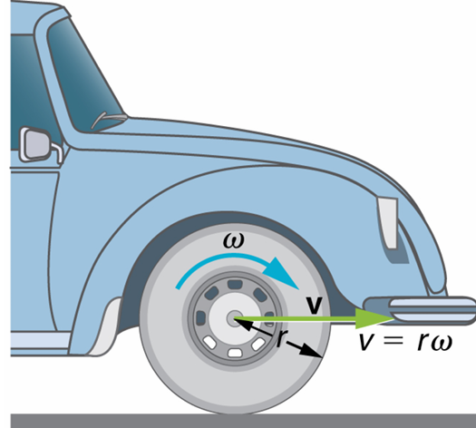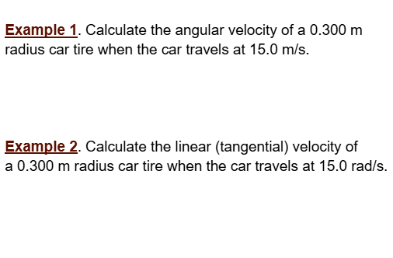

Period and Frequency for Periodic Motion

1. Period is the time taken for one complete cycle of a repeating event. It is measured in units of time, most commonly seconds (s)

2. Frequency is the number of complete cycles that occur per second. The unit is Hertz (Hz).

Period and frequency are reciprocals of each other:
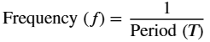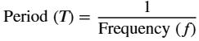

Example 3:
a) Pendulum: If a pendulum takes 2 seconds to swing back and forth once, the period is ________,

and the frequency is _________________.

b) Earth's Orbit: The period of Earth's orbit around the sun is ___________(approximately_____days,

_________________) seconds), and its frequency is 1 orbit per year, or _______________ in HZ.

Relation between Period, Frequency, and Angular Velocity:

Speed=$\frac{Distance}{Time}$ Velocity=$\frac{Displacement}{Time}$ Angular Velocity=$\frac{Angular Displacement}{Time}$

v=$\frac{d}{t}$ v=$\frac{x}{t}$ $ω=\frac{θ}{t}$

For circular motion after a complete cycle, time taken is period T, angular displacement is $θ=2π$,
Thus, $ω=\frac{θ}{t}=\frac{2π}{T}$, or
$T=\frac{2π}{ω}$, $ω=\frac{2π}{T}=2πf, f$ is the frequency.

For circular motion after a complete cycle, time taken is period T, linear displacement is $x=2πR$,
Thus, v=$\frac{x}{t}=\frac{2πR}{T}$, or
$v=\frac{2πR}{T}, T=\frac{2πR}{v}, T$is the period of the circular motion.

$ω=\frac{Δθ}{t}$ , $v=rω$, $T=\frac{1}{f}$, $T=\frac{2π}{ω}$, $ω=2πf,$ $v=\frac{2πR}{T}$
Example 4: The first Ferris Wheel, built in 1889, had a radius of 38 meters. Assume that the carts at the rim of the wheel move at a constant speed of 1.8m/s.
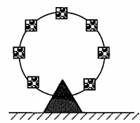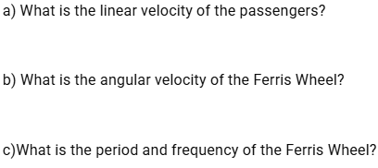

d) If a cart#8 is placed half-way from the center of the Ferris wheel, what is the linear velocity of cart#8? What is the angular velocity of cart#8?

e) What is the Rotational angle(angular displacement) of the carts at the edge after 10 seconds?

Example 5: It takes 78 seconds for a student driver to circle three times around a suburban rotary at a constant speed of 12 m/s.
a) What is the period of student’s circular motion? What is the frequency?

b) What is the radius of student’s circular motion?

c) What is the linear velocity of the student? What is her angular velocity?

d) What is the centripetal acceleration of student’s circular motion?

Centrepital Acceleration

In kinematics, acceleration is a change in velocity, either in its magnitude or in its direction, or both.

In uniform circular motion, the direction of the velocity changes constantly, so there is always an associated acceleration, even though the magnitude of the velocity might be constant.

You experience this acceleration yourself when you turn a corner in your car. What you notice is a sideways acceleration because you and the car are changing direction. The sharper the curve and the greater your speed, the more noticeable this acceleration will become.

Next, we examine the direction and magnitude of that acceleration.

The diagram below shows an object moving in a circular path at constant speed. The direction of the instantaneous velocity is shown at two points along the path. Acceleration is in the direction of the change in velocity, which points directly toward the center of rotation (the center of the circular path).

This pointing is shown with the vector diagram in the figure. We call the acceleration of an object moving in uniform circular motion (resulting from a net external force) the centripetal acceleration. Centripetal means “toward the center” or “center seeking.”
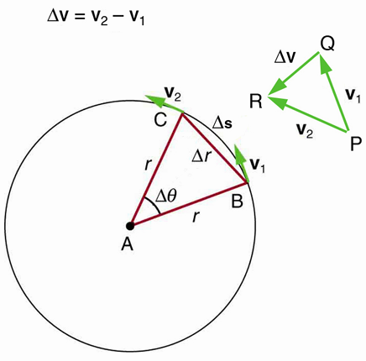
Magnitude of Centripetal Acceleration:
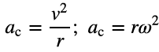
Direction of Centripetal Acceleration:
Pointing to the center of the circle (center of the rotation)

How Does the Centripetal Acceleration of a Car Around a Curve Compare with That Due to Gravity? What is the magnitude of the centripetal acceleration of a car following a curve of radius 500 m at a speed of 25.0 m/s (about 90 km/h)? Compare the acceleration with that due to gravity for this fairly gentle curve taken at highway speed.
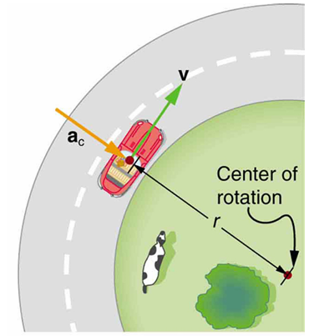

HW and Practice Problems:
$ω=\frac{Δθ}{t}$ , $v=rω$, $T=\frac{1}{f}$, $T=\frac{2π}{ω}$, $ω=2πf,$ $v=\frac{2πR}{T}$ $a_{c}=\frac{v^{2}}{R}$ $a_{c}=ω^{2}R$

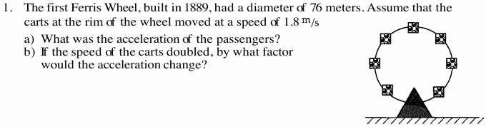

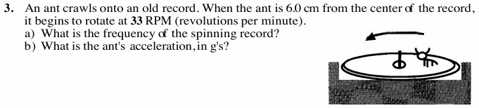

$ω=\frac{Δθ}{t}$ , $v=rω$, $T=\frac{1}{f}$, $T=\frac{2π}{ω}$, $T=2πf,$ $v=\frac{2πR}{T}$ $a_{c}=\frac{v^{2}}{R}$ $a_{c}=ω^{2}R$
